Student Worksheet: Phosphorus Life Cycle
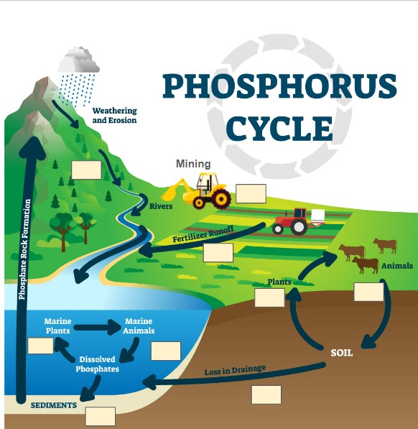

Extraction: | Decomposition:
Uptake: | Runoff:

Write the definition for each term in the boxes.

Indicate on the phosphorus cycle where the following processes may occur:
(A) Decomposition, (B) Runoff, (C) Extraction, (D) Uptake

